**Contents**

**Topic**

1. Introduction …………………………………..……………………………………………….3
   1. Purpose………………………………………………………………………………..4
2. Software and Hardware Requirement………………………………………………….……..5
3. Literature Survey……………………………………………………………………………..6
   1. Technical feasibility…………………………………………………………………..6
   2. Operational feasibility…………………………………………………………...……6
   3. Economical Feasibility……………………………………………………………..…7
4. Code Optimization……………………………………………………………..……………..8
5. Output Screen……………………………………………………………………….……….42
6. Conclusion…………………………………..……………………………………………….48
7. Future Enhancement……………………………………………………………...………….49
8. APPENDICES ………………………………………………………………………………50
9. Reference………………………………….………………………………...……………….51
10. Bibliography ………………………………………………………………...………………52

# **Project Title**

**LIBRARY MANAGEMENT SYTEM**

Technology Used: **C++ Technology (File handling as database)**

Language: **C++**

Model Type: **Individual**

College: **Lakshmi Narain College of Technology**

**Report Format**

Submitted Department: T&P

Submitted To : Rambabu Lovewanshi

Name of student : Mayank Raj

Branch : EC

Semester : 5th

Enrollment No: : 0103EC181084

Submission Date : 31-DEC-2020

1. **Introduction**

A Library management system is a software that uses to maintain the record of the library. It contains work like the number of available books in the library, the number of books are issued or returning or renewing a book or late fine charge record, etc. Library Management Systems is software that helps to maintain a database that is useful to enter new books & record books borrowed by the members, with the respective submission dates. Moreover, it also reduces the manual record burden of the librarian.

Library management system allows the librarian to maintain library resources in a more operative manner that will help to save their time. It is also convenient for the librarian to manage the process of books allotting and making payment. Library management system is also useful for students as well as a librarian to keep the constant track of the availability of all books in a store.

Project Library Management system allows librarian to keep track of

all books along with their quantity, manage issued books and also keep the data which book was issued to which student.

* 1. **Purpose**
* A library management system is the most proficient and easy to use system for managing all the processes involved in a Library in the most effective ways.
* This system will reduce all the manual work and the whole process can be managed just through single clicks and edits.
* There will be no headache and doubtfulness of storing the data securely and searching the records of any individual afterward.
* Any book seeker can rent a book just by signing in with their details, and return it with the date of returning.
* The staff can also facilitate themselves with some extra authorizations and privileges.
* Only, one person is required to take care of the whole system, without any chances of mistakes.
* It reduces the manual paperwork through it and gives proper information of books has been recorded automatically.

1. **Software and Hardware requirements**

**SOFTWARE REQUIREMENTS SPECIFICATION**

**Operating System** : Windows 10

**Programming Language**  : C++

**Database : File Handling**

**HARDWARE REQUIREMENTS SPECIFICATION**

**Processor :** Pentium IV processor or higher

**RAM :** Minimum of 1GB RAM

**Memory :** 500 MB or higher

1. **Literature survey /Review of Literature**

**INTRODUCTION**

A feasibility study is a high-level capsule version of the entire System analysis and Design Process. The study begins by classifying the problem definition. Feasibility is to determine if it’s worth doing. Once an acceptance problem definition has been generated, the analyst develops a logical model of the system. A search for alternatives is analyzed carefully. There are 3 parts in feasibility study.

**3.1 TECHNICAL FEASIBILITY**

Evaluating the technical feasibility is the trickiest part of a feasibility study. This is because, at this point in time, not too many detailed design of the system, making it difficult to access issues like performance, costs on (on account of the kind of technology to be deployed) etc. A number of issues have to be considered while doing a technical analysis. Understand the different technologies involved in the proposed system before commencing the project we have to be very clear about what are the technologies that are to be required for the development of the new system. Find out whether the organization currently possesses the required technologies. Is the required technology available with the organization?.

**3.2 OPERATIONAL FEASIBILITY**

Proposed project is beneficial only if it can be turned into information systems that will meet the organizations operating requirements. Simply stated, this test of feasibility asks if the system will work when it is developed and installed. Are there major barriers to Implementation? Here are questions that will help test the operational feasibility of a project:

* Is there sufficient support for the project from management from users? If the current system is well liked and used to the extent that persons will not be able to see reasons for change, there may be resistance.
* Are the current business methods acceptable to the user? If they are not, Users may welcome a change that will bring about a more operational and useful systems.
* Have the user been involved in the planning and development of the project?
* Early involvement reduces the chances of resistance to the system and in general and increases the likelihood of successful project.

Since the proposed system was to help reduce the hardships encountered. In the existing manual system, the new system was considered to be operational feasible.

**3.3 ECONOMIC FEASIBILITY**

Economic feasibility attempts to weigh the costs of developing and implementing a new system, against the benefits that would accrue from having the new system in place. This feasibility study gives the top management the economic justification for the new system. A simple economic analysis which gives the actual comparison of costs and benefits are much more meaningful in this case. In addition, this proves to be a useful point of reference to compare actual costs as the project progresses. There could be various types of intangible benefits on account of automation. These could include increased customer satisfaction, improvement in product quality better decision making timeliness of information, expediting activities, improved accuracy of operations, better documentation and record keeping, faster retrieval of information, better employee morale.

1. **CODE SNIPPETS FOR TRAINING**

#include<iostream>

#include<stdio.h>

#include<stdlib.h>

#include<fstream>

#include<string.h>

#include<conio.h>

using namespace std;

class Lib

{

public:

char bookname[100],auname[50],sc[20],sc1[50];

int q,B,p;

Lib()

{

strcpy(bookname,"NO Book Name");

strcpy(auname,"No Author Name");

strcpy(sc,"No Book ID");

strcpy(sc1,"No Book ID");

q=0;

B=0;

p=0;

}

void get();

void student();

void pass();

void librarian();

void password();

void getdata();

void show(int);

void booklist(int);

void modify();

void see(int);

int branch(int);

void issue();

void der(char[],int,int);

void fine(int,int,int,int,int,int);

};

void Lib::getdata()

{

int i;

fflush(stdin);

cout<<"\n\t\tEnter the details :-\n";

cout<<"\n\t\tEnter Book's Name : ";

cin.getline(bookname,100);

for(i=0;bookname[i]!='\0';i++)

{

if(bookname[i]>='a'&&bookname[i]<='z')

bookname[i]-=32;

}

cout<<"\n\t\tEnter Author's Name : ";

cin.getline(auname,50);

cout<<"\n\t\tEnter Publication name : ";

cin.getline(sc1,50);

cout<<"\n\t\tEnter Book's ID : ";

cin.getline(sc,20);

cout<<"\n\t\tEnter Book's Price : ";

cin>>p;

cout<<"\n\t\tEnter Book's Quantity : ";

cin>>q;

}

void Lib::show(int i)

{

cout<<"\n\t\tBook Name : "<<bookname<<endl;

cout<<"\n\t\tBook's Author Name : "<<auname<<endl;

cout<<"\n\t\tBook's ID : "<<sc<<endl;

cout<<"\n\t\tBook's Publication : "<<sc1<<endl;

if(i==2)

{

cout<<"\n\t\tBook's Price : "<<p<<endl;

cout<<"\n\t\tBook's Quantity : "<<q<<endl;

}

}

void Lib::booklist(int i)

{

int b,r=0;

system("cls");

b=branch(i);

system("cls");

ifstream intf("Booksdata.txt",ios::binary);

if(!intf)

cout<<"\n\t\tFile Not Found.";

else

{

cout<<"\n\t ************ Book List ************ \n\n";

intf.read((char*)this,sizeof(*this));

while(!intf.eof())

{

if(b==B)

{

if(q==0 && i==1)

{

}

else

{

r++;

cout<<"\n\t\t********** "<<r<<". ********** \n";

show(i);

}

}

intf.read((char*)this,sizeof(*this));

}

}

cout<<"\n\t\tPress any key to continue.....";

getch();

system("cls");

if(i==1)

student();

else

librarian();

}

void Lib::modify()

{

char ch,st1[100];

int i=0,b,cont=0;

system("cls");

cout<<"\n\t\t>>Please Choose one option :-\n";

cout<<"\n\t\t1.Modification In Current Books\n\n\t\t2.Add New Book\n\n\t\t3.Delete A Book\n\n\t\t4.Go back\n";

cout<<"\n\n\t\tEnter your choice : ";

cin>>i;

if(i==1)

{

system("cls");

b=branch(2);

ifstream intf1("Booksdata.txt",ios::binary);

if(!intf1)

{

cout<<"\n\t\tFile Not Found\n";

cout<<"\n\t\tPress any key to continue.....";

getch();

system("cls");

librarian();

}

intf1.close();

system("cls");

cout<<"\n\t\tPlease Choose One Option :-\n";

cout<<"\n\t\t1.Search By Book Name\n\n\t\t2.Search By Book's ID\n";

cout<<"\n\t\tEnter Your Choice : ";

cin>>i;

fflush(stdin);

if(i==1)

{

system("cls");

cout<<"\n\t\tEnter Book Name : ";

cin.getline(st1,100);

system("cls");

fstream intf("Booksdata.txt",ios::in|ios::out|ios::ate|ios::binary);

intf.seekg(0);

intf.read((char*)this,sizeof(*this));

while(!intf.eof())

{

for(i=0;b==B&&bookname[i]!='\0'&&st1[i]!='\0'&&(st1[i]==bookname[i]||st1[i]==bookname[i]+32);i++);

if(bookname[i]=='\0'&&st1[i]=='\0')

{

cont++;

getdata();

intf.seekp(intf.tellp()-sizeof(*this));

intf.write((char*)this,sizeof(*this));

break;

}

intf.read((char*)this,sizeof(*this));

}

intf.close();

}

else if(i==2)

{

cout<<"\n\t\tEnter Book's ID : ";

cin.getline(st1,100);

system("cls");

fstream intf("Booksdata.txt",ios::in|ios::out|ios::ate|ios::binary);

intf.seekg(0);

intf.read((char*)this,sizeof(*this));

while(!intf.eof())

{

for(i=0;b==B&&sc[i]!='\0'&&st1[i]!='\0'&&st1[i]==sc[i];i++);

if(sc[i]=='\0'&&st1[i]=='\0')

{

cont++;

getdata();

intf.seekp(intf.tellp()-sizeof(*this));

intf.write((char*)this,sizeof(*this));

break;

}

intf.read((char*)this,sizeof(*this));

}

intf.close();

}

else

{

cout<<"\n\t\tIncorrect Input.....:(\n";

cout<<"\n\t\tPress any key to continue.....";

getch();

system("cls");

modify();

}

if(cont==0)

{

cout<<"\n\t\tBook Not Found.\n";

cout<<"\n\t\tPress any key to continue.....";

getch();

system("cls");

modify();

}

else

cout<<"\n\t\tUpdate Successful.\n";

}

else if(i==2)

{

system("cls");

B=branch(2);

system("cls");

getdata();

ofstream outf("Booksdata.txt",ios::app|ios::binary);

outf.write((char*)this,sizeof(*this));

outf.close();

cout<<"\n\t\tBook added Successfully.\n";

}

else if(i==3)

{

system("cls");

b=branch(2);

ifstream intf1("Booksdata.txt",ios::binary);

if(!intf1)

{

cout<<"\n\t\tFile Not Found\n";

cout<<"\n\t\tPress any key to continue.....";

getch();

intf1.close();

system("cls");

librarian();

}

intf1.close();

system("cls");

cout<<"\n\t\tPlease Choose One Option for deletion:-\n";

cout<<"\n\t\t1.By Book Name\n\n\t\t2.By Book's ID\n";

cout<<"\n\t\tEnter Your Choice : ";

cin>>i;

fflush(stdin);

if(i==1)

{

system("cls");

cout<<"\n\t\tEnter Book Name : ";

cin.getline(st1,100);

ofstream outf("temp.txt",ios::app|ios::binary);

ifstream intf("Booksdata.txt",ios::binary);

intf.read((char*)this,sizeof(*this));

while(!intf.eof())

{

for(i=0;b==B&&bookname[i]!='\0'&&st1[i]!='\0'&&(st1[i]==bookname[i]||st1[i]==bookname[i]+32);i++);

if(bookname[i]=='\0'&&st1[i]=='\0')

{

cont++;

intf.read((char*)this,sizeof(*this));

}

else

{

outf.write((char*)this,sizeof(*this));

intf.read((char*)this,sizeof(*this));

}

}

intf.close();

outf.close();

remove("Booksdata.txt");

rename("temp.txt","Booksdata.txt");

}

else if(i==2)

{

cout<<"\n\t\tEnter Book's ID : ";

cin.getline(st1,100);

ofstream outf("temp.txt",ios::app|ios::binary);

ifstream intf("Booksdata.txt",ios::binary);

intf.read((char*)this,sizeof(*this));

while(!intf.eof())

{

for(i=0;b==B&&sc[i]!='\0'&&st1[i]!='\0'&&st1[i]==sc[i];i++);

if(sc[i]=='\0'&&st1[i]=='\0')

{

cont++;

intf.read((char*)this,sizeof(*this));

}

else

{

outf.write((char*)this,sizeof(*this));

intf.read((char*)this,sizeof(*this));

}

}

outf.close();

intf.close();

remove("Booksdata.txt");

rename("temp.txt","Booksdata.txt");

}

else

{

cout<<"\n\t\tIncorrect Input.....:(\n";

cout<<"\n\t\tPress any key to continue.....";

getch();

system("cls");

modify();

}

if(cont==0)

{

cout<<"\n\t\tBook Not Found.\n";

cout<<"\n\t\tPress any key to continue.....";

getch();

system("cls");

modify();

}

else

cout<<"\n\t\tDeletion Successful.\n";

}

else if(i==4)

{

system("cls");

librarian();

}

else

{

cout<<"\n\t\tWrong Input.\n";

cout<<"\n\t\tPress any key to continue.....";

getch();

system("cls");

modify();

}

cout<<"\n\t\tPress any key to continue.....";

getch();

system("cls");

librarian();

}

int Lib::branch(int x)

{

int i;

cout<<"\n\t\t>>Please Choose one Branch :-\n";

cout<<"\n\t\t1.CS/IT\n\n\t\t2.EE\n\n\t\t3.EC\n\n\t\t4.CIVIL\n\n\t\t5.MECHANICAL\n\n\t\t6.1ST YEAR\n\n\t\t7.Go to menu\n";

cout<<"\n\t\tEnter youur choice : ";

cin>>i;

switch(i)

{

case 1: return 1;

break;

case 2: return 2;

break;

case 3: return 3;

break;

case 4: return 4;

break;

case 5: return 5;

break;

case 6: return 6;

break;

case 7: system("cls");

if(x==1)

student();

else

librarian();

default : cout<<"\n\t\tPlease enter correct option :(";

getch();

system("cls");

branch(x);

}

}

void Lib::see(int x)

{

int i,b,cont=0;

char ch[100];

system("cls");

b=branch(x);

ifstream intf("Booksdata.txt",ios::binary);

if(!intf)

{

cout<<"\n\t\tFile Not Found.\n";

cout<<"\n\t\t->Press any key to continue.....";

getch();

system("cls");

if(x==1)

student();

else

librarian();

}

system("cls");

cout<<"\n\t\tPlease Choose one option :-\n";

cout<<"\n\t\t1.Search By Name\n\n\t\t2.Search By Book's ID\n";

cout<<"\n\t\tEnter Your Choice : ";

cin>>i;

fflush(stdin);

intf.read((char*)this,sizeof(*this));

if(i==1)

{

cout<<"\n\t\tEnter Book's Name : ";

cin.getline(ch,100);

system("cls");

while(!intf.eof())

{

for(i=0;b==B&&q!=0&&bookname[i]!='\0'&&ch[i]!='\0'&&(ch[i]==bookname[i]||ch[i]==bookname[i]+32);i++);

if(bookname[i]=='\0'&&ch[i]=='\0')

{

cout<<"\n\t\tBook Found :-\n";

show(x);

cont++;

break;

}

intf.read((char*)this,sizeof(*this));

}

}

else if(i==2)

{

cout<<"\n\t\tEnter Book's ID : ";

cin.getline(ch,100);

system("cls");

while(!intf.eof())

{

for(i=0;b==B&&q!=0&&sc[i]!='\0'&&ch[i]!='\0'&&ch[i]==sc[i];i++);

if(sc[i]=='\0'&&ch[i]=='\0')

{

cout<<"\n\t\tBook Found :-\n";

show(x);

cont++;

break;

}

intf.read((char*)this,sizeof(*this));

}

}

else

{

cont++;

cout<<"\n\t\tPlease enter correct option :(";

getch();

system("cls");

see(x);

}

intf.close();

if(cont==0)

cout<<"\n\t\tThis Book is not available :( \n";

cout<<"\n\t\tPress any key to continue.....";

getch();

system("cls");

if(x==1)

student();

else

librarian();

}

void Lib::issue()

{

char st[50],st1[20];

int b,i,j,d,m,y,dd,mm,yy,cont=0;

system("cls");

cout<<"\n\t\t->Please Choose one option :-\n";

cout<<"\n\t\t1.Issue Book\n\n\t\t2.View Issued Book\n\n\t\t3.Search student who isuued books\n\n\t\t4.Reissue Book\n\n\t\t5.Return Book\n\n\t\t6.Go back to menu\n\n\t\tEnter Your Choice : ";

cin>>i;

fflush(stdin);

if(i==1)

{

system("cls");

b=branch(2);

system("cls");

fflush(stdin);

cout<<"\n\t\t->Please Enter Details :-\n";

cout<<"\n\t\tEnter Book Name : ";

cin.getline(bookname,100);

cout<<"\n\t\tEnter Book's ID : ";

cin.getline(sc,20);

//strcpy(st,sc);

der(sc,b,1);

cout<<"\n\t\tEnter Student Name : ";

cin.getline(auname,100);

cout<<"\n\t\tEnter Student's ID : ";

cin.getline(sc1,20);

cout<<"\n\t\tEnter date : ";

cin>>q>>B>>p;

ofstream outf("student.txt",ios::binary|ios::app);

outf.write((char*)this,sizeof(*this));

outf.close();

cout<<"\n\n\t\tIssue Successfully.\n";

}

else if(i==2)

{

ifstream intf("student.txt",ios::binary);

system("cls");

cout<<"\n\t\t->The Details are :-\n";

intf.read((char*)this,sizeof(*this));

i=0;

while(!intf.eof())

{

i++;

cout<<"\n\t\t********** "<<i<<". ********** \n";

cout<<"\n\t\tStudent Name : "<<auname<<"\n\t\t"<<"Student's ID : "<<sc1<<"\n\t\t"<<"Book Name : "<<bookname<<"\n\t\t"<<"Book's ID : "<<sc<<"\n\t\t"<<"Date : "<<q<<"/"<<B<<"/"<<p<<"\n";

intf.read((char*)this,sizeof(*this));

}

intf.close();

}

else if(i==3)

{

system("cls");

fflush(stdin);

cout<<"\n\t\t->Please Enter Details :-\n";

cout<<"\n\n\t\tEnter Student Name : ";

cin.getline(st,50);

cout<<"\n\n\t\tEnter Student's ID : ";

cin.getline(st1,20);

system("cls");

ifstream intf("student.txt",ios::binary);

intf.read((char*)this,sizeof(*this));

cont=0;

while(!intf.eof())

{

for(i=0;sc1[i]!='\0'&&st1[i]!='\0'&&st1[i]==sc1[i];i++);

if(sc1[i]=='\0'&&st1[i]=='\0')

{

cont++;

if(cont==1)

{

cout<<"\n\t\t->The Details are :-\n";

cout<<"\n\t\tStudent Name : "<<auname;

cout<<"\n\t\tStudent's ID : "<<sc1;

}

cout<<"\n\n\t\t******* "<<cont<<". Book details *******\n";

cout<<"\n\t\tBook Name : "<<bookname;

cout<<"\n\t\tBook's ID : "<<sc;

cout<<"\n\t\tDate : "<<q<<"/"<<B<<"/"<<p<<"\n";

}

intf.read((char*)this,sizeof(*this));

}

intf.close();

if(cont==0)

cout<<"\n\t\tNo record found.";

}

else if(i==4)

{

system("cls");

fflush(stdin);

cout<<"\n\t\t->Please Enter Details :-\n";

cout<<"\n\n\t\tEnter Student's ID : ";

cin.getline(st,50);

cout<<"\n\t\tEnter Book's ID : ";

cin.getline(st1,20);

fstream intf("student.txt",ios::in|ios::out|ios::ate|ios::binary);

intf.seekg(0);

intf.read((char*)this,sizeof(*this));

while(!intf.eof())

{

for(i=0;sc[i]!='\0'&&st1[i]!='\0'&&st1[i]==sc[i];i++);

for(j=0;sc1[j]!='\0'&&st[j]!='\0'&&st[j]==sc1[j];j++);

if(sc[i]=='\0'&&sc1[j]=='\0'&&st[j]=='\0'&&st1[i]=='\0')

{

d=q;

m=B;

y=p;

cout<<"\n\t\tEnter New Date : ";

cin>>q>>B>>p;

fine(d,m,y,q,B,p); //fn1

intf.seekp(intf.tellp()-sizeof(*this)); //fn3

intf.write((char*)this,sizeof(*this)); //fn5

cout<<"\n\n\t\tReissue successfully."; //fn3

break;

}

intf.read((char*)this,sizeof(*this));

}

intf.close();

}

else if(i==5)

{

system("cls");

b=branch(2);

system("cls");

fflush(stdin);

cout<<"\n\t\t->Please Enter Details :-\n";

cout<<"\n\t\tEnter Book's ID : ";

cin.getline(st1,20);

der(st1,b,2);

cout<<"\n\n\t\tEnter Student's ID : ";

cin.getline(st,20);

cout<<"\n\t\tEnter Present date : ";

cin>>d>>m>>y;

ofstream outf("temp.txt",ios::app|ios::binary);

ifstream intf("student.txt",ios::binary);

intf.read((char*)this,sizeof(*this));

while(!intf.eof())

{

for(i=0;sc[i]!='\0'&&st1[i]!='\0'&&st1[i]==sc[i];i++);

for(j=0;sc1[j]!='\0'&&st[j]!='\0'&&st[j]==sc1[j];j++);

if(sc[i]=='\0'&&sc1[j]=='\0'&&st[j]=='\0'&&st1[i]=='\0'&&cont==0)

{

cont++;

intf.read((char*)this,sizeof(*this));

fine(q,B,p,d,m,y);

cout<<"\n\t\tReturned successfully.";

}

else

{

outf.write((char*)this,sizeof(*this));

intf.read((char*)this,sizeof(*this));

}

}

intf.close();

outf.close();

getch();

remove("student.txt");

rename("temp.txt","student.txt");

}

else if(i==6)

{

system("cls");

librarian();

}

else

cout<<"\n\t\tWrong Input.\n";

cout<<"\n\n\t\tPress any key to continue.....";

getch();

system("cls");

librarian();

}

void Lib::fine(int d,int m,int y,int dd,int mm,int yy)

{

long int n1,n2;

int years,l,i;

const int monthDays[12] = {31, 28, 31, 30, 31, 30,31, 31, 30, 31, 30, 31};

n1 = y*365 + d;

for (i=0; i<m - 1; i++)

n1 += monthDays[i]; //fn1353

years = y;

if (m <= 2)

years--;

l= years / 4 - years / 100 + years / 400;

n1 += l;

n2 = yy*365 + dd;

for (i=0; i<mm - 1; i++)

n2 += monthDays[i];

years = yy;

if (m <= 2)

years--;

l= years / 4 - years / 100 + years / 400;

n2 += l;

n1=n2-n1;

n2=n1-15;

if(n2>0)

cout<<"\n\t\tThe Total Fine is : "<<n2;

}

void Lib::der(char st[],int b,int x)

{

int i,cont=0;

fstream intf("Booksdata.txt",ios::in|ios::out|ios::ate|ios::binary);

intf.seekg(0);

intf.read((char*)this,sizeof(*this));

while(!intf.eof())

{

for(i=0;b==B&&sc[i]!='\0'&&st[i]!='\0'&&st[i]==sc[i];i++);

if(sc[i]=='\0'&&st[i]=='\0')

{

cont++;

if(x==1)

{

q--;

}

else

{

q++;

}

intf.seekp(intf.tellp()-sizeof(*this));

intf.write((char*)this,sizeof(*this));

break;

}

intf.read((char*)this,sizeof(*this));

}

if(cont==0)

{

cout<<"\n\t\tBook not found.\n";

cout<<"\n\n\t\tPress any key to continue.....";

getch();

system("cls");

issue();

}

intf.close();

}

void Lib::get()

{

int i;

cout<<"\n\t*********** LIBRARY MANAGEMENT SYSTEM IN C++ ***********\n"<<"\n\t\t\t";

cout<<"\n\t\t>>Please Choose Any Option To login \n";

cout<<"\n\t\t1.Student\n\n\t\t2.Librarian\n\n\t\t3.Close Application\n";

cout<<"\n\t\tEnter your choice : ";

cin>>i;

if(i==1)

{

system("cls");

student();

}

else if(i==2)

pass();

else if(i==3)

exit(0);

else

{

cout<<"\n\t\tPlease enter correct option :(";

getch();

system("CLS");

get();

}

}

void Lib::student()

{

int i;

cout<<"\n\t************ WELCOME STUDENT ************\n";

cout<<"\n\t\t>>Please Choose One Option:\n";

cout<<"\n\t\t1.View BookList\n\n\t\t2.Search for a Book\n\n\t\t3.Go to main menu\n\n\t\t4.Close Application\n";

cout<<"\n\t\tEnter your choice : ";

cin>>i;

if(i==1)

booklist(1);

else if(i==2)

see(1);

else if(i==3)

{

system("cls");

get();

}

else if(i==4)

exit(0);

else

{

cout<<"\n\t\tPlease enter correct option :(";

getch();

system("cls");

student();

}

}

void Lib::pass()

{

int i=0;

char ch,st[21],ch1[21]={"pass"};

cout<<"\n\t\tEnter Password : ";

while(1)

{

ch=getch();

if(ch==13)

{

st[i]='\0';

break;

}

else if(ch==8&&i>0)

{

i--;

cout<<"\b \b";

}

else

{

cout<<"*";

st[i]=ch;

i++;

}

}

ifstream inf("password.txt");

inf>>ch1;

inf.close();

for(i=0;st[i]==ch1[i]&&st[i]!='\0'&&ch1[i]!='\0';i++);

if(st[i]=='\0'&&ch1[i]=='\0')

{

system("cls");

librarian();

}

else

{

cout<<"\n\n\t\tWrong Password.\n\n\t\ttry again.....\n";

getch();

system("cls");

get();

}

}

void Lib::librarian()

{

int i;

cout<<"\n\t************ WELCOME LIBRARIAN ************\n";

cout<<"\n\t\t>>Please Choose One Option:\n";

cout<<"\n\t\t1.View BookList\n\n\t\t2.Search for a Book\n\n\t\t3.Modify/Add Book\n\n\t\t4.Issue Book\n\n\t\t5.Go to main menu\n\n\t\t6.Change Password\n\n\t\t7.Close Application\n";

cout<<"\n\t\tEnter your choice : ";

cin>>i;

switch(i)

{

case 1:booklist(2);

break;

case 2:see(2);

break;

case 3:modify();

break;

case 4:issue();

break;

case 5:system("cls");

get();

break;

case 6:password();

break;

case 7:exit(0);

default:cout<<"\n\t\tPlease enter correct option :(";

getch();

system("cls");

librarian();

}

}

void Lib::password()

{

int i=0,j=0;

char ch,st[21],ch1[21]={"pass"};

system("cls");

cout<<"\n\n\t\tEnter Old Password : ";

while(1)

{

ch=getch();

if(ch==13)

{

st[i]='\0';

break;

}

else if(ch==8&&i>0)

{

i--;

cout<<"\b \b";

}

else

{

cout<<"*";

st[i]=ch;

i++;

}

}

ifstream intf("password.txt");

intf>>ch1;

intf.close();

for(i=0;st[i]==ch1[i]&&st[i]!='\0'&&ch1[i]!='\0';i++);

if(st[i]=='\0'&&ch1[i]=='\0')

{

system("cls");

cout<<"\n\t**The Password Should be less than 20 characters & don't use spaces**\n\n";

cout<<"\n\t\tEnter New Password : ";

fflush(stdin);

i=0;

while(1)

{

j++;

ch=getch();

if(ch==13)

{

for(i=0;st[i]!=' '&&st[i]!='\0';i++);

if(j>20 || st[i]==' ')

{

cout<<"\n\n\t\tYou did't follow the instruction \n\n\t\tPress any key for try again.....";

getch();

system("cls");

password();

librarian();

}

st[i]='\0';

break;

}

else if(ch==8&&i>0)

{

i--;

cout<<"\b \b";

}

else

{

cout<<"*";

st[i]=ch;

i++;

}

}

ofstream outf("password.txt");

outf<<st;

outf.close();

cout<<"\n\n\t\tYour Password has been changed Successfully.";

cout<<"\n\t\tPress any key to continue......";

getch();

system("cls");

librarian();

}

else

{

cout<<"\n\n\t\tPassword is incorrect.....\n";

cout<<"\n\t\tEnter 1 for retry or 2 for menu";

cin>>i;

if(i==1)

{

system("cls");

password();

}

else

{

system("cls");

librarian();

}

}

}

int main()

{

Lib obj;

obj.get();

getch();

return 0;

}

1. **Output Screens**

The following shows the series of output screens and how the actual process of implementing Library Management System takes place:-

Our Project’s Home page look like this:-

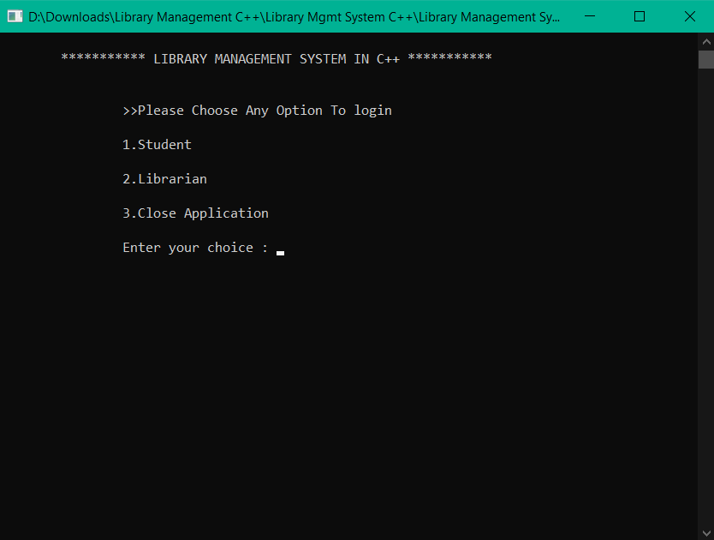

**MENU FOR STUDENTS:-**

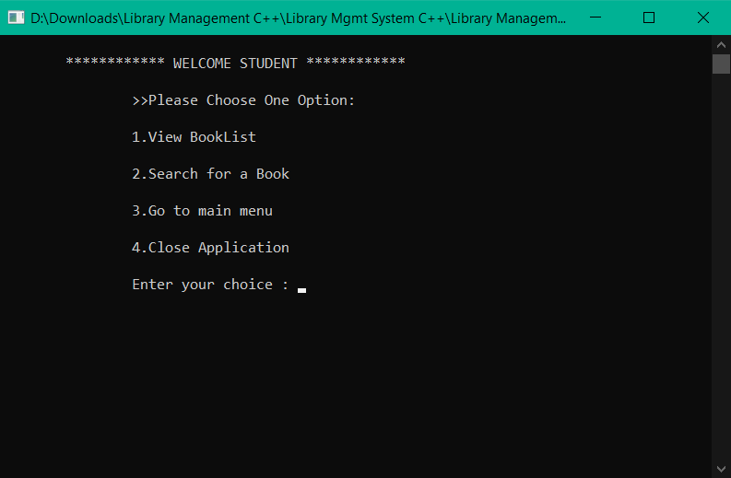

**MENU FOR LIBRARIAN:-**

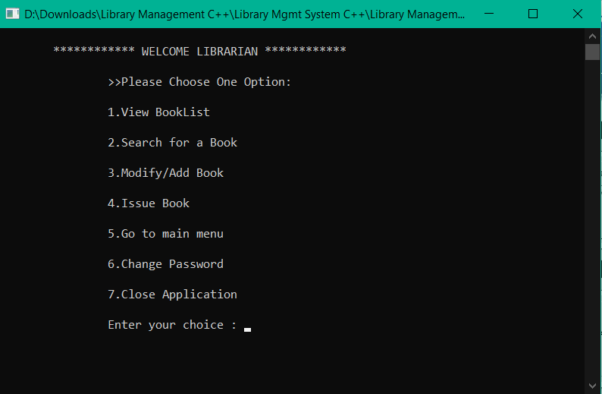

**CATEGORIZATION OF BOOKS BRANCH WISE:-**



**VIEW BOOKS:-**

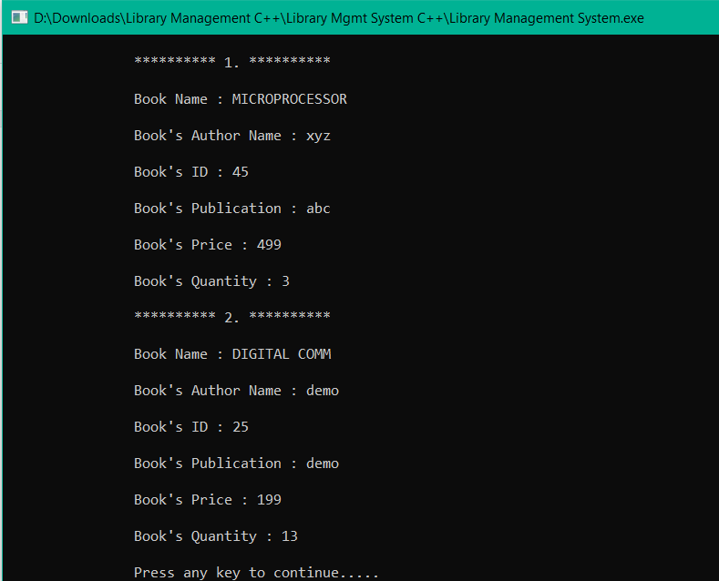

**ISSUE OF BOOKS:-**

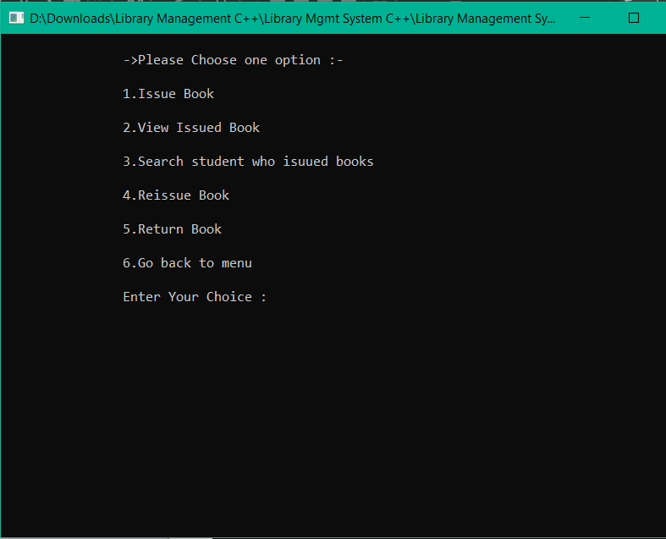

1. **Conclusion**

With the help of this project **Library Management** has become fully computerized thus reducing the time consumption and paperwork. Now it has become very easy to Keep track of all the books, add a new book, issue a book etc. Overall, with this project, we can perform all library related activities**. Library Management System** is C++ console based application without graphics. It is compiled in Code::Blocks with gcc compiler.

1. **Future Enhancements**

* All Procedure along with database can be implemented online this could save time and will became more feasible.
* It can be provided online with the help of android application

1. **APPENDICES**
2. **Appendix A: Glossary**

          All the terms and abbreviations in the project are specified clearly. For further development of project evolved definitions will be specified.

**9. References**

Under this references section, we have mentioned various references from which we collected our problem and several others that supported us to design the solution for our problem. These references include either books, papers published through some standards and several websites links with URL’s:-

1. For Complete reference of C++ refer www.geeksforgeeks.com.
2. For more references [www.google.com](http://www.google.com)
3. Refer book **Let Us C** By Yashwant kanetekar
4. [www.wikipedia.org](http://www.wikipedia.org)

**10. BIBILOGRAPHY**

* **C++**

**By** [Bjarne Stroustrup](https://www.google.com/search?sxsrf=ALeKk003xckCvsS4N_sR0DeEsHGztbmAmw:1609405505811&q=Bjarne+Stroustrup&stick=H4sIAAAAAAAAAONgVuLQz9U3MDRPSnnEaMwt8PLHPWEprUlrTl5jVOHiCs7IL3fNK8ksqRQS42KDsnikuLjgmngWsQo6ZSUW5aUqBJcU5ZcWlxSVFgAADVQdqFYAAAA)